Angular is a client-side JavaScript Framework for adding interactivity to HTML.

A Directive is a marker on HTML tag that tells Angular to run or reference some JavaScript code.

**Directive**

* The **ng-model** directive binds the value of HTML controls (input, select, textarea) to application data.
* The **ng-app** directive defines an AngularJS application.
* The **ng-bind** directive binds application data to the HTML view.

**Modules**

* Where we write pieces of our Angular application
* Makes our code more maintainable, testable ,and readable
* Where we define dependencies for our app

Create our first module with the file **app.js**

var app=angular.module('store',[]);

store is an Application Name, [] describe the dependencies

We should include app.js file into the html file ,by using the following line

<script type="text/javascript" src="app.js"></script>

Using the **ng-app** directive to run this module when the document loads

<html ng-app="store">

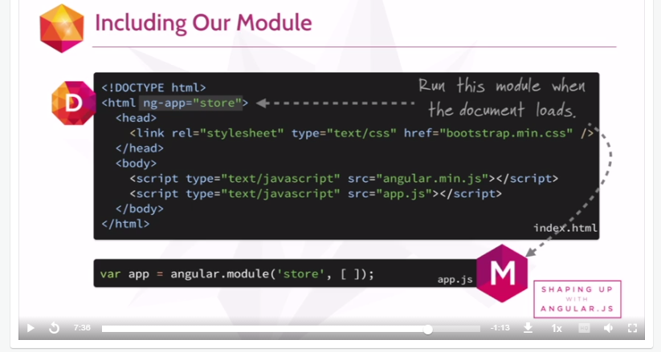

**Expressions**

Allow you to insert dynamic values into your HTML.

More Operations:

http://docs.angularjs.org/guide/expression

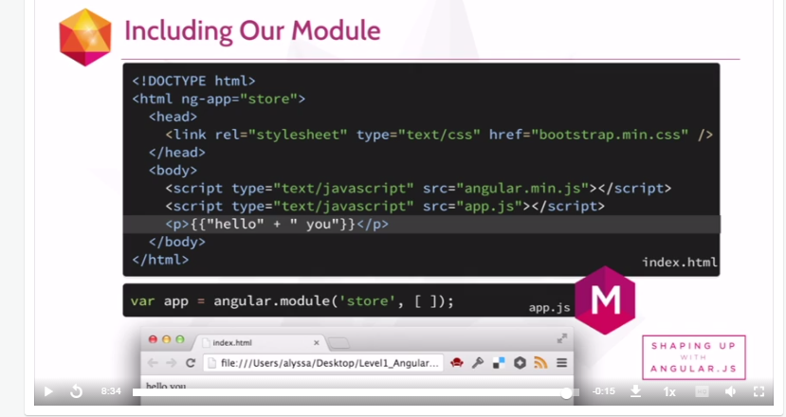

**Controllers**

Controllers are where we define our apps behaviour by defining functions and values

Wrapping your Javascript in a closure is a good habit

Notice that Controller is attached to inside our app.